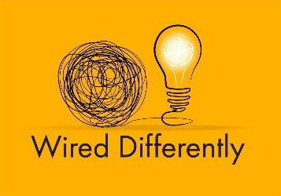

Wired Differently by Sara-Louise Ackrill Ltd
124 City Road
London
EC1V 2NX
UK

sara.ackrill@wireddifferently.co.uk
https://www.wireddifferently.co.uk/Virtual-Assistant-Service.php

Limited Company number 13224578
UTR number 144542728297

QUOTATION TO
Name at emailaddress@gmail.com Date

Activity | Qty Hours (per week) | Rate (per hour inc VAT) | Amount
Neurodiversity Specialist Business Support | XXX | £38.40 | Total

To provide a specialist admin support worker for neurodivergent client across all business functions.

TOTAL XXX p/w

